TENTATIF KURSUS LINK NURSE HOSPITAL YAN
07-08/10/2024

Day 1 (07/10/2024)

MASA | AKTIVITI/CERAMAH | PENCERAMAH
8.00am-8.30am | Pendaftaran Kursus | Urusetia
8.30am-8.45am | Bacaan Doa & Perasmian Kursus | Urusetia
9.00am-9.45am | Hand Hygiene | KUP Marina binti Omar
9.45am-10.30am | PPE | KUP Rozita binti Osman
10.30am-11.00am | Minum pagi | Urusetia
11.00am-11.45am | Phlebitis | Matron Rumaizah binti Abu Hassan
11.45am-12.30pm | Wound dressing | KJ Kharul Uminiza binti Md Akhir
12.30pm-1.00pm | Kuiz | Urusetia
1.00pm-2.00pm | Makan/Rehat/Solat | Urusetia
2.00pm-4.00pm | OSCEE  - Wound dressing  -IVD insertion  -PPE  -Hand Hygiene  -CBD insertion | Fasilitator
4.00pm-5.00pm | Perbincangan standard 5 akreditasi | Dr Janahan a/l Devaraj

Day 2 (08/10/2024)

MASA | AKTIVITI/CERAMAH | PENCERAMAH
8.00am-8.30am | Pendaftaran Kursus | Urusetia
8.30am-8.45am | Bacaan Doa & Perasmian Kursus | Urusetia
9.00am-9.45am | See what the others can’t see | Dr. Noor Hasliza binti Zainol
9.45am-10.30am | Spread kindness not germs | Dr. Nor Alfazita binti Am@Amran
10.30am-11.00am | Minum pagi | Urusetia
11.00am-1.00pm | Audit pematuhan kawalan infeksi | Fasiitator
1.00pm-2.00pm | Makan/Rehat/Solat | Urusetia
2.00pm-2.45pm | Pembentangan Audit pematuhan kawalan infeksi | Fasiitator
2.45pm-5.00pm | Mesyuarat PCI Team | PCI Team

Sekapur sirih seulas pinang

“Ucapan terima kasih yang tidak terhingga kepada urusetia dan
fasilitator yang terlibat dalam menjayakan kursus Link Nurse kali ini.”

Kursus link nurse
Hospital Yan

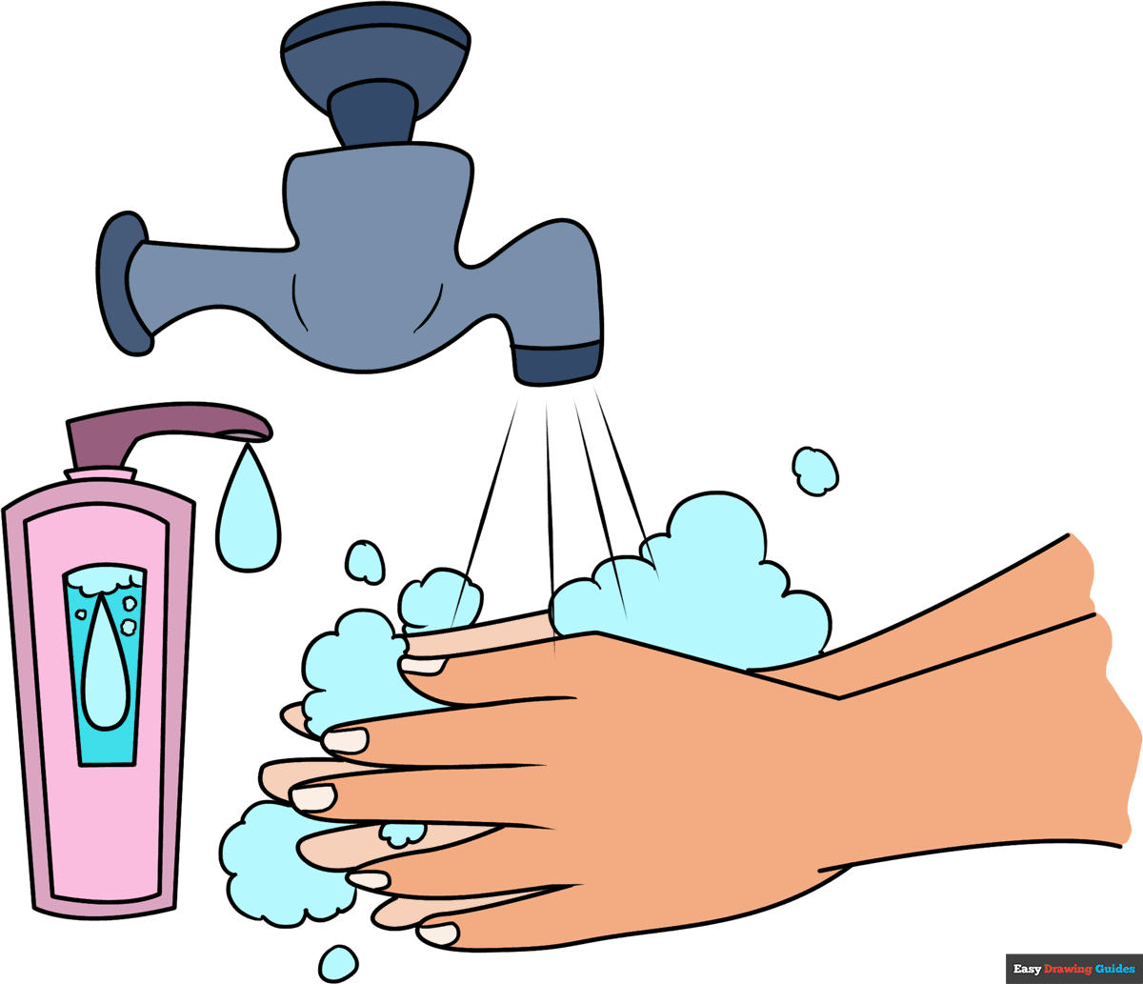
07-08/10/2024

DEWAN PERASA

